**NAME: SOFIA AAMIR**

**REGISTRATION NO: FA21-BSE-036**

**OOSE MID LAB**

**PROCESS CONSUMPTION (ELECTRICITY METER):**

* **MAIN SUCCESS SCENERIO:**

The main success scenario against the process consumption process in Electricity theft detection shows that how people are involving in using the electricity and if they are using the electricity in illegal way the system will detect it. Here is the step by step success scenario of the process consumption that these things will happen against it:

**Data Collection:** The system collects electricity consumption data from various sources such as smart meters and many other sources. This data includes information on the amount of electricity used by each customer in each specific period of time.

**Data Preprocessing:** The collected data is processed to remove errors or inconsistencies. This may involve validating the data, handling missing values, and normalizing the consumption values.

**Pattern Analysis:** The system analyzes the consumption(usage) patterns of each customer to establish a baseline or expected consumption profile. This profile is created by considering factors such as historical consumption data, weather conditions, and customer characteristics.

**Alarm Generation:** When the system detects an inconsistency in a customer's consumption pattern, it generates an alarm to alert the utility company or relevant authorities about the suspicious activity. The alarm may include details such as the customer's identity, the nature of the anomaly, and the severity of the potential theft.

**Investigation and Verification:** Upon receiving the alarm, the utility company initiates an investigation into the flagged customer's account. They may conduct further analysis or on-site inspections to verify the presence of electricity theft. This could involve physical inspections, meter readings, or collaboration with law enforcement agencies.

**Action and Legal Proceedings:** If the investigation confirms the occurrence of electricity theft, appropriate actions are taken. This may involve disconnecting the illegal connections, imposing penalties, initiating legal proceedings against the perpetrators, or recovering the stolen electricity charges.

**Monitoring and Prevention:** The system continuously monitors consumption patterns to detect and prevent future instances of electricity theft. It adapts and updates the baseline consumption profiles based on changing customer behavior, seasons, or any other relevant factors.

* **SYSTEM SEQUENCE DIAGRAM OF PROCESS CONSUMPTION:**

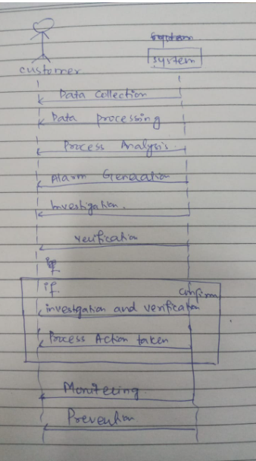

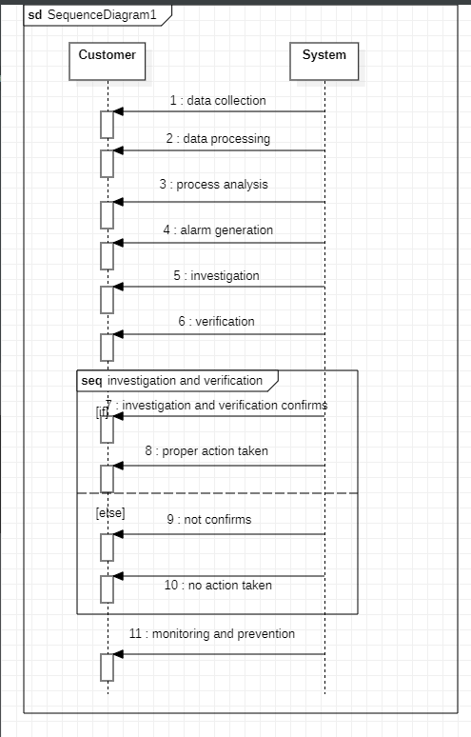

* **PROTOTYPES:**
* **MAIN PAGE:**

This is the main page in which I have taken only few functionalities. My use case is Process Consumption. If the electricity meter handler will click on process consumption button the handler will go then to Process consumption page.

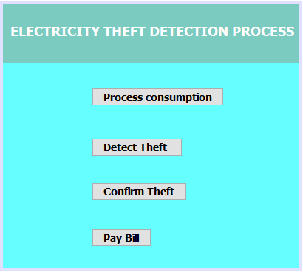

* **PROCESS CONSUMPTION PROCESS:**

After clicking on process consumption button the handler will move to anither page. There is the name of customer and cnic of customer. That will be enter by the handler and the handler will also choose that through which process the customer has steal the power. And then the handler will confirm that by clicking on confirm button.

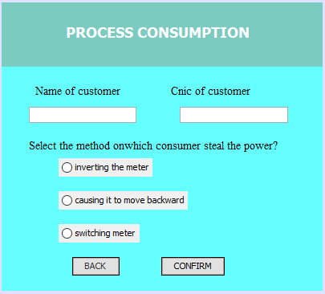

* **GENERATE ALARM PAGE:**

After clicking on confirm button on process consumption page the handler will then generate alarm for the customer.

